It’s Poetry Fun Day!
Today you’re going to explore various forms of poetry. Each poetic structure is unique. All of them have been chosen because they have rules about the SHAPE or/and the NUMBER OF SYLLABLES.

Read:
Begin by reading about each type of poetry. Read the examples aloud with your group.

Remember:
In your notebook, write down the structural rules for each form.
- How many syllables are needed?
- How many lines are there?
- What is the content of each line?

Write:
Then, try writing a poem in that style.

Choose one of the following topics if you have writer’s block.

- Life
  - Childhood
  - Aging
  - Being a Teen
- Love
  - Family
  - Romantic
  - Friendship
- Death
  - Pet
  - Family
  - Fear of Death
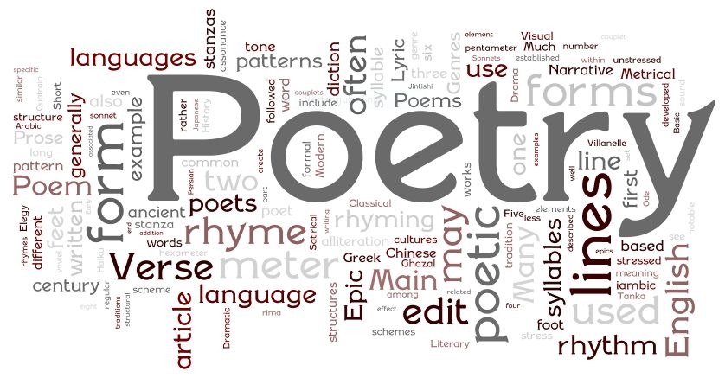
- Loss
Nature
  - Weather / Seasons
  - Favorite Place
  - Animals
- Emotions
  - Betrayal
  - Apology
  - Anger
  - Memory
- Time
- Money
- School
- Favorite Interests

