Theatrical Terms for ENG 1DI

Theatrical Devices
Allusion: A cultural reference to a well-known work, figure, or character
Genre: A type of play. Shakespeare wrote comedies, tragedies, and historical fictions
Comedy: A play that focuses on humorous situations and the prevalence of love
Comic Relief: Humor used to break the tension of a dramatic scene
Crisis: An important turning point in a story
Dramatic Irony: When the audience knows something a specific character does not
Pathos: An attempt by the author to build pity or sympathy for a character
Props: All objects, such as furniture, pictures, weapons etc., used in a performance (but not including scenery). Categorised into "hand props" and "set props" (or "set dressing")
Supernatural: A divine power extending beyond the mortal realm
Motif: A recurring image or phrase
Symbolism: An object used to represent a complex idea
Theme: A message the author sends to audiences through their work
Universal Theme: A thematic statement that transcends a specific work, and can apply to all peoples, cultures, and eras (ie. family, fate, tragedy, love, justice, etc.)

How Characters Talk & Move
Soliloquy: A speech revealing a character’s thoughts to the audience while the character is alone on stage
Blank Verse / Prose: Speech that does not rhyme or have any restrictions of meter. Often used by uneducated characters
Poetry: Structured speech, following a rhyme scheme and specific meter
Iambic Pentameter: Shakespeare’s predominant form of poetry used in his plays
Iam = Unstressed syllable followed by a stressed syllable
Penta = five
Meter = feet in a line of poetry
Foot = two syllables
Couplet: Two consecutive lines that rhyme
Motivation: Reasons behind a character’s actions
Pun: A play on words
Malapropism: Mixing up words
Paradox: A statement which seems contradictory but is actually true
Blocking: The planned movement and actions of an actor on stage.
STAGE DIRECTIONS:
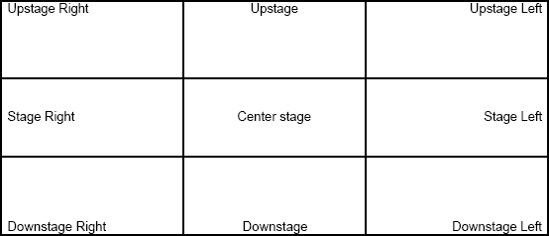

Theatrical Terms for ENG 1DI

Theatrical Devices
Allusion: A to a well-known work, figure, or character
Genre: A type of play. Shakespeare wrote
Comedy: A play that focuses on and the prevalence of
Comic Relief: Humor used to break the of a dramatic scene
Crisis: An important in a story
Dramatic Irony: When the knows something a specific character does not
Pathos: An attempt by the author to build for a character
Props: All , such as furniture, pictures, weapons etc., used in a performance (but not including scenery). Categorised into " " and " " (or "set dressing")
Supernatural: A extending beyond the mortal realm
Motif: A recurring
Symbolism: An used to represent a
Theme: A the author sends to audiences through their work
Universal Theme: A thematic statement that , and can apply to all (ie. family, fate, tragedy, love, justice, etc.)

How Characters Talk & Move
Soliloquy: A speech revealing a to the audience while the character is
Blank Verse / Prose: Speech that does not or have any . Often used by characters
Poetry: , following a rhyme scheme and specific meter
Iambic Pentameter: Shakespeare’s predominant form of used in his plays
Iam = followed by a stressed syllable
Penta =
Meter = in a line of poetry
Foot =
Couplet: Two consecutive lines that
Motivation: behind a character’s actions
Pun: A on words
Malapropism: words
Paradox: A statement which seems but is actually true
Blocking: The and actions of an actor on stage
Stage Directions:
