Name:
Collage Wallet
Everyone has many interests. Ones we like to show off to others, and ones that are more personal, that people may not know about. You are going to make a collage wallet based on your multiple interests.

Supplies:
- 3 pieces of paper (2 pieces of 3.25” x 6.5” and one piece of 2.75” x 6.5” minimum)
- Magazines (lots of pictures of your subject)
- Scissors
- Clear tape or Mac Tac
- Embroidery Floss
- Sewing Needle

Instructions:
- Cut out pictures of your two topics from magazines—you will need a lot!

- Following the rules for collage and considering unity, over the paper with pictures. The small piece (2.75” x 6.5”) must be covered on one side. One of the larger pieces of paper must be covered completely on one side with a 1” overhang on the other side, and on the last piece the top 1” will be covered on both sides.

Optional: you can cut a hole in the middle of one of the smaller sheets for an ID window, or add extra pockets to hold more cards.

- Cover each piece with clear packing tape or Mac Tac. Work slowly and carefully so that you don’t get wrinkles. If you do get wrinkles do not flatten them! Use an X-acto knife to slice the wrinkle open and then press it down. Burnish the surface of the collage with something hard and smooth (like a spoon) to get rid of air bubbles.

Tip: Ensure you understand which way is facing up on each piece so your wallet is properly constructed.

- Optional: if you have access to a sewing machine, sew a line of holes 1/8” all around all three pieces. Use no thread, and set the machine to its widest stitch.

When punching holes, ensure that all pieces stay lined up (with tape or safety pins).

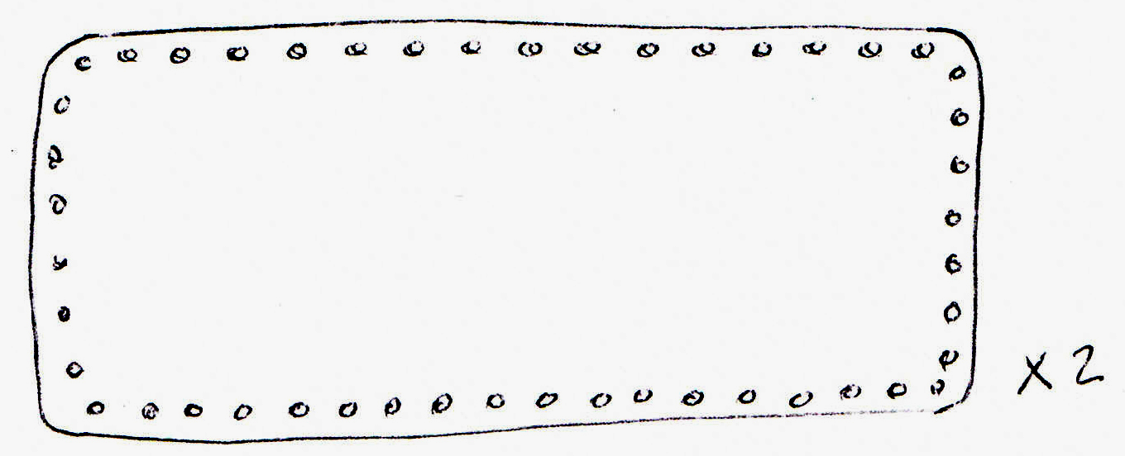
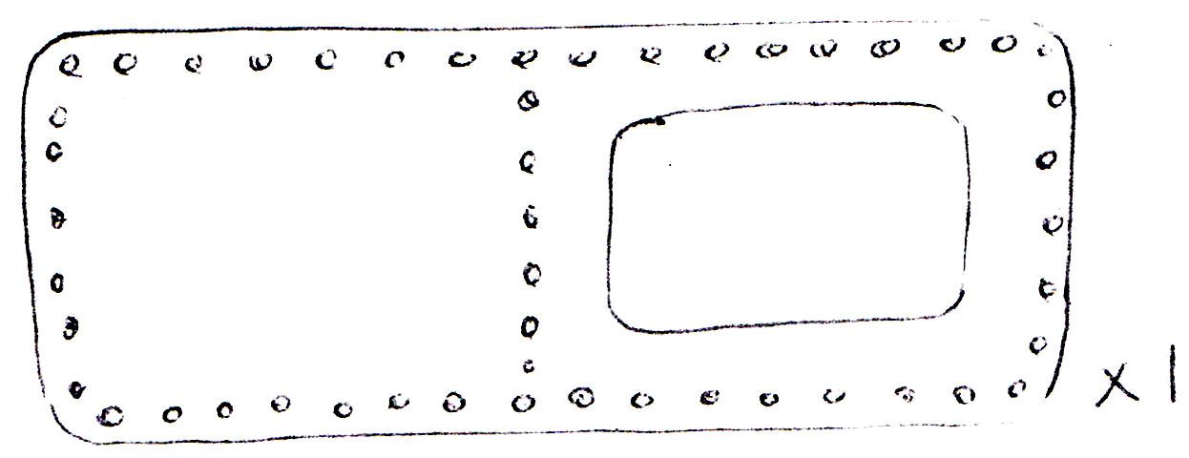

- With two strands of embroidery floss, overcast or blanket stitch the top edges of each piece.
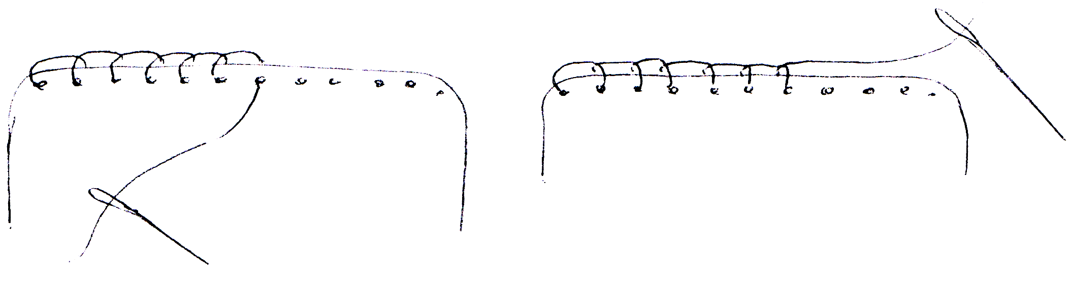

- Sew the smallest piece and the single collage together along the centre line by using a backstitch.
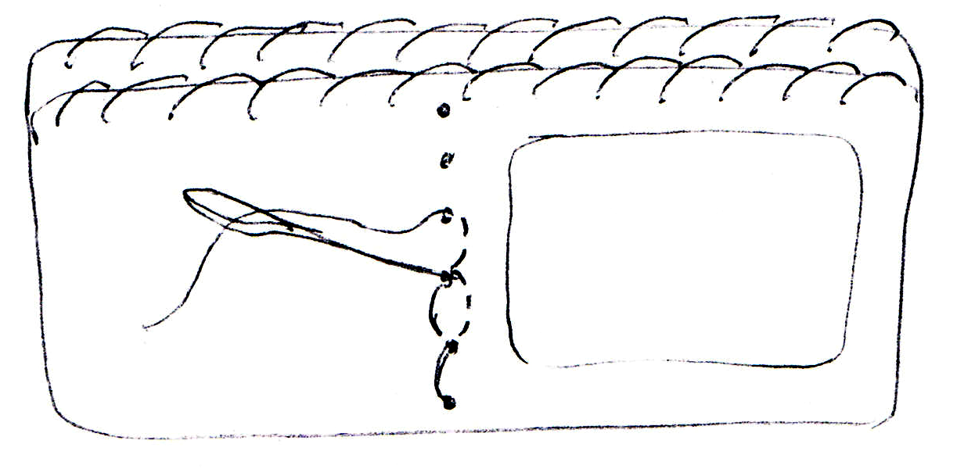
- Assemble the pieces. The large collage piece is the back, the smallest piece is the inside, and the other piece is sandwiched between, with the collage facing out.
The stitched edges are up.

- Blanket stitch or overcast stitch all around the wallet. Hide your knots inside.
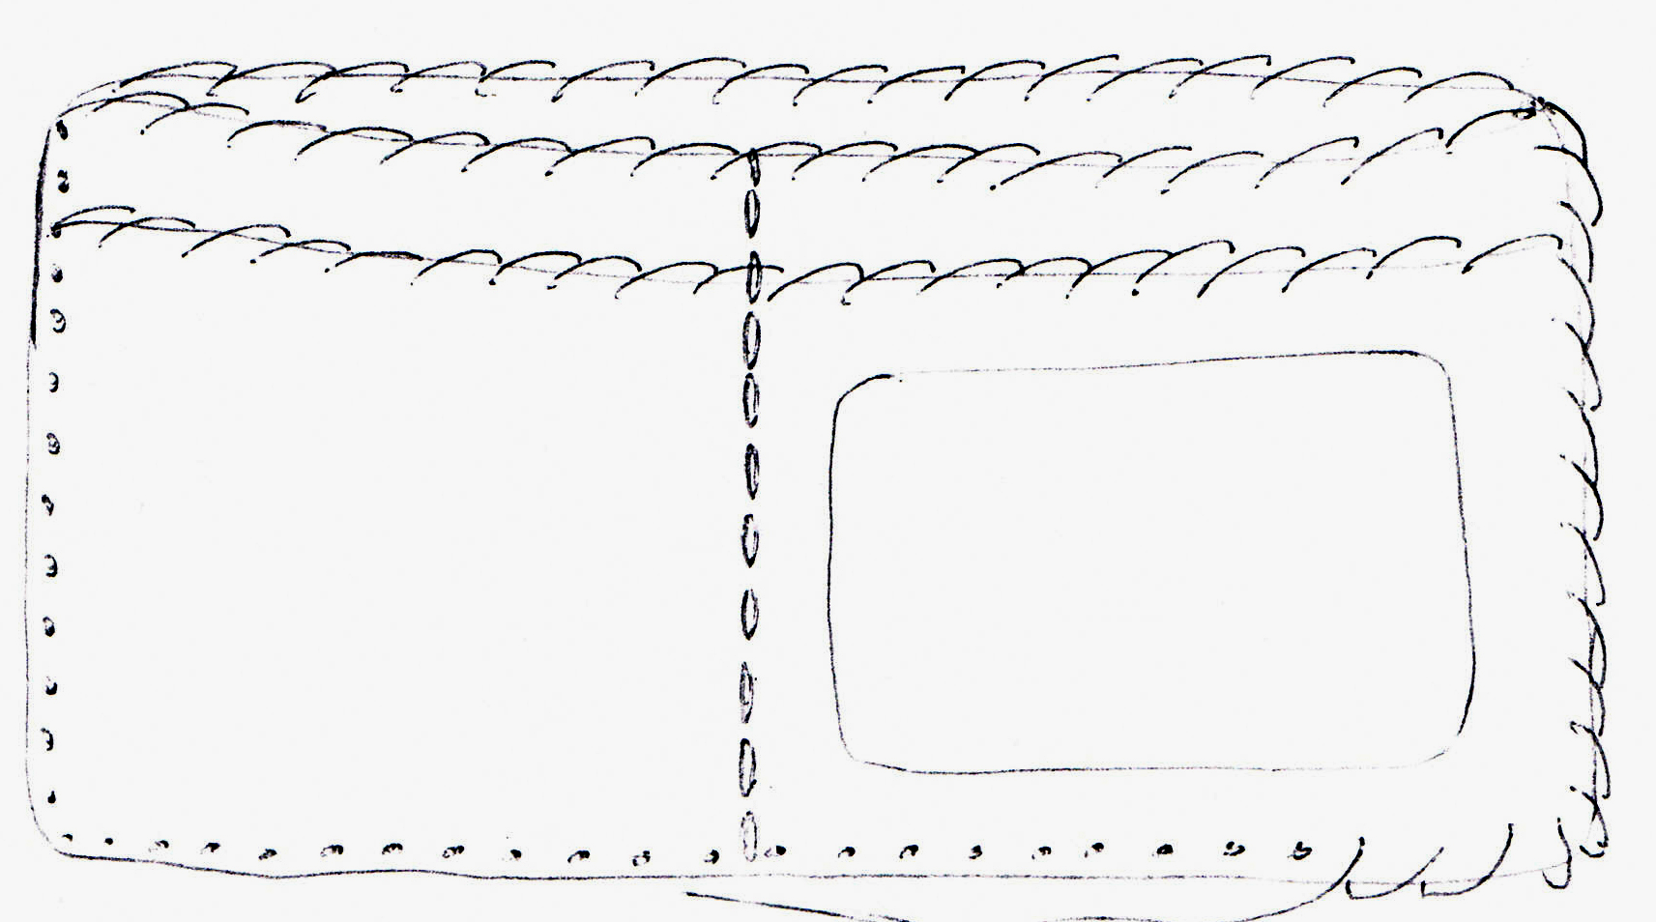

Due Date:

Evaluation: Total: _____ / 40
 | R | Level 1 | Level 2 | Level 3 | Level 4
Construction |  | -Poor stitching  -Visible visible knots  -Rough finish  -Unable to hold bills & cards  -Vinyl has not been applied | -Fair stitching  -Some visible knots  -Somewhat smooth finish  -Able to hold bills  -Vinyl applied sloppily | -Good stitching  -Few visible knots  -Smooth finish  -Able to hold bills and cards  -Vinyl has been applied | -Great stitching  -No visible knots  -Very Smooth finish  -Able to hold bills and cards  -Vinyl well applied
Themes & Message |  | -Themes are inappropriate  -Messages are unclear | -Themes are somewhat appropriate  -Messages are somewhat clear | -Themes are appropriate  -Messages are clear | -Themes are thoughtful  -Messages are persuasive
Unity & Balance |  | -Poor use of balance & unity  -Does not incorporate text and images well | -Fair use of balance & unity  -Fair incorporation of text and images | -Good use of balance & unity  -Incorporates text and images | -Excellent balance & unity  -Incorporates text and images very well
Creativity & Overall Impressions |  | -Uncreative Collage  -Threads clash with collage  -Poor overall impressions | -Somewhat Creative Collage  -Threads fit collage  -Fair overall impressions | -Creative Collage  -Threads complements collage  -Good overall impressions | -Very Creative Collage  -Threads complements collage  -Great overall impressions

