Applying Audience Theories in Media
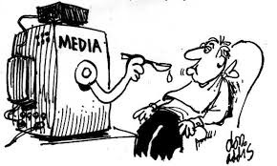
Audience Effects from Media ( ):
The focus is: What does media do to people?

Audiences exposed to
for example, repeated exposure to images of violence desensitize the audience or normalize certain behaviours.
- Example:

Audience Uses and Gratifications of Media ( ):
The focus is: What do people do with media?

The audience actively seeks out media texts or to provide them with
The audience wants to:

in the media environment

- escape from

Discussion:
What is your favourite TV show or Movie. Why do you watch it? What type of audience are you?

Applying Audience Theories in Media
Audience Effects from Media ( ):
The focus is: What does media do to people?

Audiences exposed to – for example, repeated exposure to images of violence desensitize the audience or normalize certain behaviours.
- Example:

Audience Uses and Gratifications of Media ( ):
The focus is: What do people do with media?

The audience actively seeks out media texts or to provide them with
The audience wants to:

in the media environment

- escape from

Discussion:
What is your favourite TV show or Movie. Why do you watch it? What type of audience are you?
Applying Audience Theories in Media
Audience Effects from Media (passive audience):
The focus is: What does media do to people?

Audiences exposed to particular stimuli became “conditioned” to them – for example, repeated exposure to images of violence desensitize the audience or normalize certain behaviours.
- Example: The Bobo Doll Experiment

Audience Uses and Gratifications of Media (active audience):
The focus is: What do people do with media?

The audience actively seeks out media texts that fulfil needs that they have (uses) or to provide them with pleasures (gratifications)
The audience wants to:
- be informed or educated
- identify with characters of the situation in the media environment
- simple entertainment
- enhance social interaction
- escape from the stresses of daily life

Discussion:
What is your favourite TV show or Movie. Why do you watch it? What type of audience are you?

