Name: Date:

Email an Inspirational Adult
Task:
You are to email an inspirational adult in your life (a parent, coach, favourite teacher, or mentor of sometime) and update them on how you are doing in school, and specifically English class so far this semester.
Your goals for this email are:
- To demonstrate an understanding of the email format
- To demonstrate an understanding of formal language
- To show an awareness of how you’re doing in English class
  - Something you’re proud of in this course
  - What goals you’re setting for yourself
  - Anything you wish to improve on
  - or Something fun that you’ve enjoyed in class

Process:
- Fill in the outline sheet on page 2 in point form
- Login to your waterworks email using your PAL login (http://waterworks.wrdsb.on.ca/login)
- Write your email
- Proofread your email
- CC or BCC Mr. Bignell in the email ( Chris_Bignell@WRDSB.ON.ca )
  - Do not miss this step, or your email will not be marked!
- Send it to your inspirational adult

Due Date:

Evaluation: Total: /10
Criteria | R | Level 1 | Level 2 | Level 3 | Level 4
Adheres to email format & structure
Level of thoughtfulness reflecting upon coursework
Formal style & mechanics
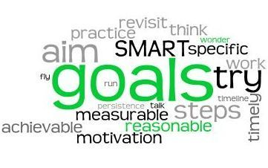

Outline:
Complete this outline in point form to organize your thoughts and ensure you have all of the required elements before typing your email.

Date:
To: (be specific with their full name & email address)

CC or BCC:
From:
Subject:
Greeting:
1st Paragraph:
Discuss how you’ve been doing (in life, school, and other interests) – catch them up from your last email.
2nd and 3rd Paragraph:
Explain how you’re doing in English class specifically. Refer to previous assignments, and explain what you did well and what you need to improve upon.
Conclusion:
Set some new goals. Consider the 4 strands of English (Oral, Writing, Reading, and Media), and how you wish to improve on them. What is your action plan for the next unit in this course?
Farewell:

