ENG 2PI Common Essay Mistakes
(aka. Common “Series of Paragraph” Errors on the Literacy Test)

- Clearly state your thesis

While it’s good to show that you’re aware of both sides of the argument in your introductory paragraph, your thesis needs to clearly state which stance you take. Don’t be a fence-sitter, and remain undecided.

Which is the more clear argument for the topic, what is the best fruit?

Thesis statements:
“Apples are delicious, and there are a lot of other healthy and yummy fruits like oranges or bananas”
Versus
“Apples are the best fruit because they are delicious and nutritious”

- Structure your argument properly

Know the proper way to organize your introductory and concluding paragraphs, as well as your body paragraphs. Use transition words, and have multiple points in each body paragraph for full marks.

Introductory Paragraph | Body Paragraph | Concluding Paragraph
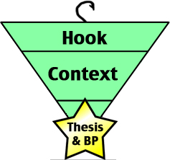  - Hook the reader with a fact about the topic  - Introduce the argument  - State your thesis formally | Topic Sentence  Point Proof Discussion  Point 2 Proof 2 Disc 2  Point 3 Proof 3 Disc 3  Concluding Sentence  - Make sure you have all the parts  - Be concise  - Use a separate sentence for each part to help distinguish between your point and proof | 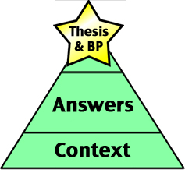  - Restate your thesis  - Draw conclusions from your argument  - End with a broad statement

- Provide specific examples

Stating “apples are yummy” without providing proof doesn’t cut it. You need to refer to specific examples.
For example:
Point: Apples are found in lots of desserts.
Proof: Examples include, apple crisp, apple blossom, apple pie, apple sauce.
Comment: Apples are so common in desserts because the majority of people find them delicious.

- Proofread for mechanical and grammatical errors

To be marked, your writing must:
- Be legible
  - Take your time and write clearly
  - Clearly indicate paragraph breaks by indenting your paragraphs
- Make sense
  - When you are finished, review your work by reading it in your head. If you think anything is unclear at this point, then fix it
  - Watch out for homonyms, and other tricky words (ie. they’re, there, and their)

