ENG 2PI Name: Date: Mr. Bignell

Grammar Poster Assignment
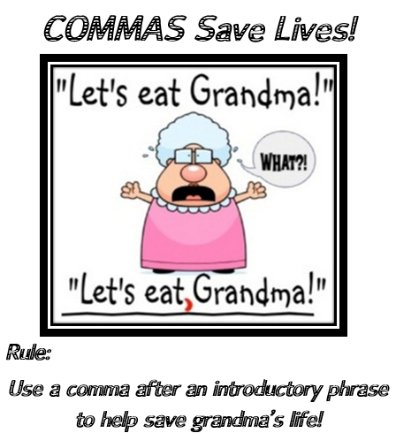
You are going to create a grammar media piece. There are multiple formats your media piece can take. Choose your media format wisely, because each format has a different emphasis on how information is conveyed.

Learning Goal: To creatively communicate one of the grammatical rules or common mistakes of grammar that we’ve studied in class.

Success Criteria:
- Be informative: Demonstrate a grammar rule or common grammar mistake
- Be professional: Pay attention to detail and be deliberate about your choices
- Be visually appealing: Consider your target audience when designing your images and examples
- Be your own work: Do NOT plagiarize. All information – from text to images – must be your own. While the web can help with ideas, what you hand in must be your own.
A plagiarized assignment will be redone. If you have questions, simply ask.
- A successful poster will have:
- A clear title depicting the grammar area
- A visual depicting the rule being broken (here’s where your Option 1, 2, and 3 are used)
- A brief explanation of the rule at the bottom of the poster.

Note: Options 1 & 2 are designed to be humorous, while Option 3 is informational.
Option 1: The Grammar Poster (see example above)
The grammar poster is a funny way to mock a common grammar mistake. Put your grammar mistake in the wrong context, and you’ve got yourself a ridiculous and hilarious situation.

Option 2: The Grammar Comic
The grammar comic also uses humor to teach audiences. For this option, you will have more flexibility when presenting your message because you can add more cells to your comic.
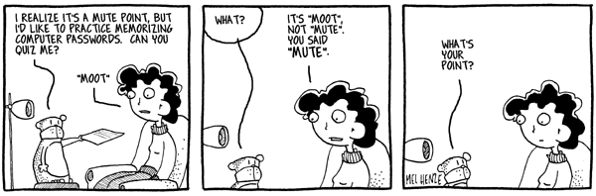

Option 3: The Grammar Infographic
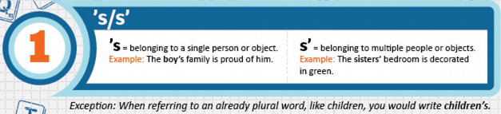
Infographics are designed to present information is a visually friendly manner. Unlike option 1 and 2, they’re not usually designed to be humorous. With the Infographic option, you can use a flow chart to explain one of the grammar rules we’ve studied in this course. For this option, use a heading, use your own example of the grammar rule being broken, and then provide the rule.

Each pair of students will do its own topic. Please put a star next to your top 3 favourites.
Grammar Topic | RUBRIC  Criteria Level 1 Level 2 Level 3 Level 4  Information:  Conveys grammar rule with accuracy and purpose  Professionalism:  Strong attention to detail and choices  Well-suited option to topic and rule  Aesthetics:  Layout, target audience, and elements of design  Content:  Mandatory components satisfied
- Subject-Verb Agreement
- Commas (NOT as above)
- Comma Splice Errors
- Run-On Sentences
- Sentence Fragments
- Misplaced Modifiers
- Dangling Modifiers
- Pluralizing Nouns
- Apostrophes (NOT as above)
- Homonyms
- Common Misspellings (NOT as above)
- Using Adverbs Properly

ENG 2PI Name: Date: Mrs. Blaak

Grammar Assignment Formative Worksheet
Step 1 | Choose Partner and Get Contact Info | My partner is….  I can reach him / her by…
Step 2 | Receive on grammar topic | Our topic is…
Step 3 | Our specific area of focus  (only one aspect of the grammar topic; you cannot tackle it all)
Step 4 | Brainstorm Ideas for each option  Option 1: Poster Option 2: Comic Option 3: Infographic
Step 5 | Decide on Option from Brainstorming | We pick (from 3 options above)….
Step 6 | Begin planning  - What information will you put on poster | Title at the top:  Example of misuse (for poster, it’s the humourous, brief error. For comic, it’s the whole text of the comic strip. For infographic, it’s a wrong example).  Rule or Correction at the bottom (write exactly how you will word it):
Step 7 | GET YOUR IDEAS PASSED BY YOUR TEACHER before moving on to be sure your errors are the errors they should be, and to be sure the correction / rule is accurate | Mrs. Blaak Signs Here (do not move on without her initials)
Step 8 | Design your Visuals  - What style of text will you use? Lay it out on a rough paper.  - What image will you have? Who will draw it?  - In what style will you present your rule?  - All text should be big enough to fill a poster.
Step 9 | Draw up good copy and polish
Step 10 | Submit

