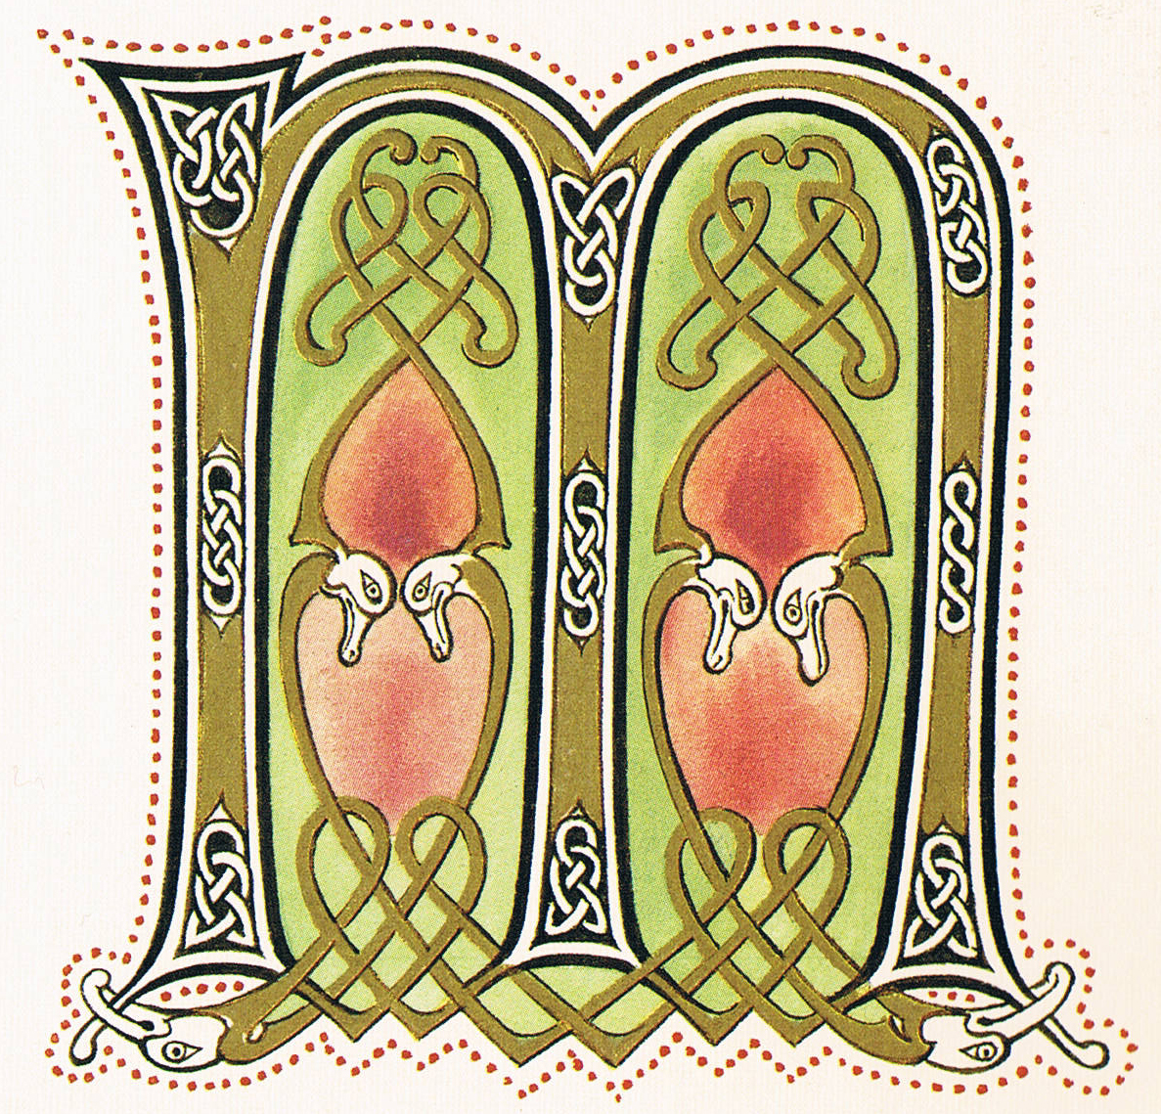
EDIEVAL ART
Name:

Date:

The Medieval Period took place in from
until . Many people lived in areas, although cities had begun to develop. Society was founded on and the system. Christianity was important to society because it caused the vast majority of people (the poor) to focus on the afterlife, and not revolt against the powers that be.

The system is a social hierarchy, in which everything belongs to the monarch (King or Queen). It is important to note that in this system, your life is only valuable if you possess land. The monarch gave land to the , who were important people who were part of the royal court. They would then partition the land they were give, and give it to , who were knights that protected the land. Once land had been given, it was considered a which was passed down through generations through inheritance. Everyone without land lived a life of poverty, working farms or trades to feed their families. Finally, the monarch’s money is replenished through .

Three major art styles of the time are: , , & .
Major art forms consist of: .

In the Medieval period, books were written by hand onto (sheep or goat skin) by monks, as only the clergy and extremely wealthy were literate. Texts were decorated, and often the letter(s) was intricately designed. The colour schemes consisted of rich, dark colours to contrast the parchment as it aged. Some texts were , which applies gold or silver shavings to add vibrancy to the illustrations. This process is why we call these decorative letters letters. Most texts were religious, and belonged to churches and the wealthy. Finally, are the last area of decoration. Less important books were leather bound, however, some religious texts had gold and silver covers.

