Name: Date:
Motive “Pushover” Analysis Questions
Characters & Archetypes:
Identify an archetype for each character. Then list any unique characteristics that make that character realistic.
Character | Role / Archetype | Unique Characteristics
Angie Flynn
Oscar Vega
Scott Hayward
Ben Crewson
Liane Heatley
Randy Sprague

Atmosphere:
Use the chart below to analyze the atmosphere in a specific scene that Mr. Bignell selects.
Scene: |  | Atmosphere:
Elements of media | Example from film |  | How it builds the atmosphere
Visual Element
(lighting / colour)
Sound Element
(music / sound FX)
Editing
(camera / editing)

Why-Done-It Genre:
Is the Why-Done-It more or less appealing than the traditional Who-Done-It? Why does this appeal to you as an audience member?

Femme Fatale Characters:
Use a Vhenn Diagram to compare Liane Heatley from Motive to Eve Cressey from “I’ll Be Waiting”. Evaluate each character in terms of their intentions, innocence, and danger. Are these women villains? Why are they dangerous?
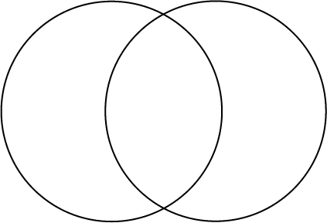

Laine Eve
Heatley Cressey

Social Implications Class Discussions:
As a class, discuss the Femme Fatale archetype. Do you think it is founded on social biases of misogyny or mistrust of women? Consider the time period when each was written (2013 and 1933 respectively). Is this archetype intriguing or offensive? Explain your position with references to the texts.
Motive “Pushover”

Characters & Archetypes
Identify an archetype for each character. Provide an example from the show to justify your archetype choice.

Angie Flynn (Detective)
Oscar Vega (Detective)
Scott Hayward (Victim / Limo Driver)
Ben Crewson (Killer / Customs Officer)
Liane Heatley (Waitress)
Randy Sprague (Lawyer)

