Name: Date:

Lord of the Flies Media Piece

Get ready to unleash your creative side, because you’ve been contracted to design the new book jacket OR movie poster for the anniversary edition of Lord of the Flies. Your efforts will be assessed for their aesthetic appeal, as well as the thought and explanation of your creative decisions, so be sure to work through all of the steps of the creative process. Note that all images and text used must be original to avoid plagiarism.

Creative Process:
- Brainstorm: List the key elements of the novel you wish to emphasize in your work. Since symbolism is so important to the novel, you should include at least one symbol in your work.
- Thumbnails: Once you’ve decided what you want on your media piece, try using various layouts of information (both text and images). Try various positioning, sizes, values, and colours to play around with different emphasis.
- Discuss: Refinement happens when we discuss our ideas and consider critical feedback. Share your thumbnails with a peer or teacher to discuss which design is strongest, and why.
- Rough Draft: On an 8.5x11” piece of paper, layout where everything will go. You do not have to colour and shade things on your rough draft, but you should make some indications of your colour scheme and value layout. Write out all of your text to make sure you use proper spelling and grammar, and that it fits within the parameters you intend to use on your final draft.
- Final Draft: Create the final piece on an 8.5x11” piece of paper (minimum, you may go larger if you wish). Be sure to fill the white space with colour, value, or any other designs you’ve chosen.

Content / Format:

Book Jacket elements include:
- A front, spine, and back to the jacket
- 5mm of bleed space around the boarder
- Book title
- Author’s name
- Publisher information
- Critical acclaim
- Awards
- A brief description (limiting spoilers)
- Image(s) depicting essential elements
Review the diagram below to ensure you have the correct spacing.

Movie Poster elements include:
- 5mm of bleed space around the boarder
- Movie title
- Director, producer, and actors’ names and previous famous works
- Critical acclaim
- Awards
- Tagline
- Website
- Image(s) depicting critical scene(s)
Review the diagram below to ensure you have the correct spacing.
Justification:
Each submission must be accompanied by an informal, 100-200 word, MLA formatted explanation of your creative decisions. This is a chance to explain the significance of your symbols, colour, layout, value, etc.. If you lack in creative talent, your explanation is critical to the assessment of your thought process.

Submission Date(s):
Thumbnail / Peer Editing Date:

Final Submission & Justification Due:

Evaluation:
 | Criteria | R | Lv 1 | Lv 2 | Lv 3 | Lv 4
Media | Creative Process: |  |  |  | - Uses the drafting process appropriately  - Critical thought demonstrated in planning
 | Content / Layout: |  |  |  | - All elements are included  - Text and images are intriguing  - Strong connections to the text  - Minimal mechanical or formatting errors
 | Aesthetics: |  |  |  | - Emphasis is purposefully placed  - Good level of detail is demonstrated
Justification | Explanation: |  |  |  | - Ample thought given to the elements of design  - Creative choices are well justified with references
 | Formatting: |  |  |  | - Adheres to MLA formatting with minimal errors  - Adheres to the word limit
 | Style: |  |  |  | - Writing style is persuasive and convincing  - No mechanical or grammatical errors

Book Jacket Template

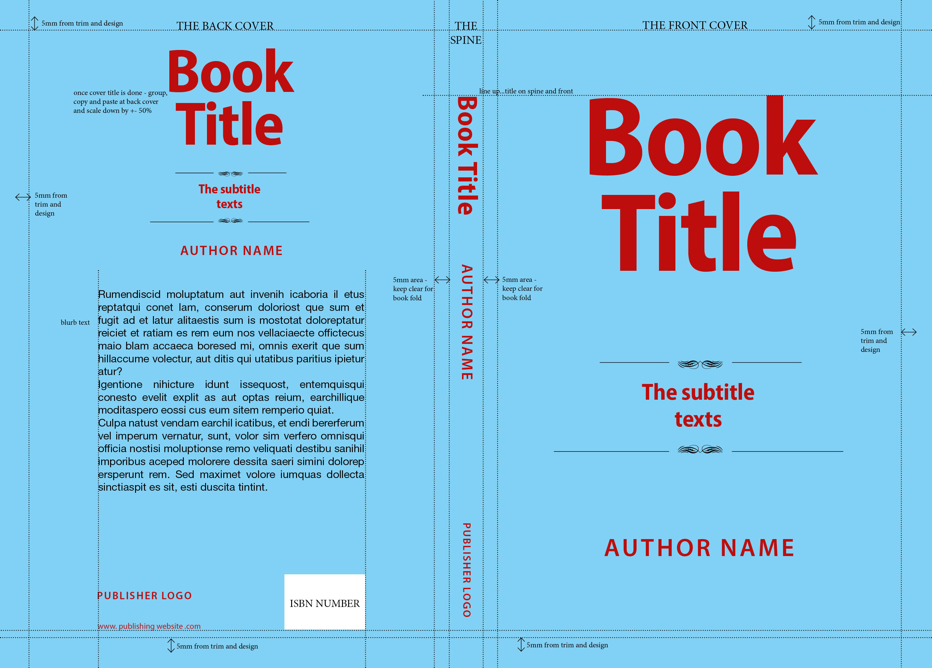

Movie Poster Template

