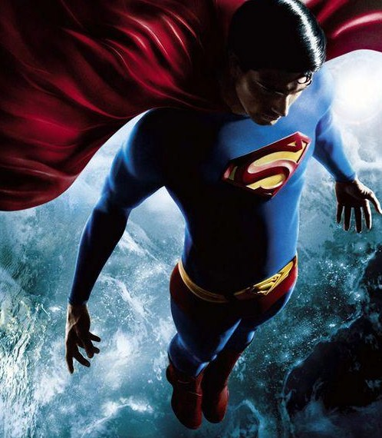
The Characteristics of a Mythical Hero

  - A hero has a mysterious or unusual birth

  - A hero is usually semi-divine. This means that his mother or father is a god or goddess.

  - Superhuman powers or abilities are attributes of the hero. For example, Hercules was exceptionally strong.

- Heroes also have outstanding characteristics such as being very smart or very brave.

- The hero must go on a quest, which is a journey, to find something (often a treasure), fight a monster or save a princess. The hero must overcome physical and mental challenges or obstacles on his quest.

- The hero has a sidekick or posse. A sidekick is a person who helps the hero complete his quest or overcome obstacles and is willing to give up his life for the hero, although he seldom has to die to show his devotion. A posse is a group of people who fulfill the sidekick function.

- Charisma (the ability to make others feel enthusiasm or devotion) is a characteristic the hero possesses. People love them and want to do things for them.

