Scare Tactics in the Media
  - How horror techniques are used in the media

Horror Techniques:

- grotesque images
- dark atmosphere
- innocent victims
- horrific/evil being attacking people
- characters fight against evil
- message - punishment or overcoming evil

All these used in the media

How the media uses Fear:
- media uses fear to influence the opinions and actions of others
- use exaggeration and graphic images
- repeat similar messages (in different forms) to reinforce message
- ex: ad campaigns, news report updates...
News | Advertising
"If it bleeds, it leads"  1) over exaggerate importance or prevalence of events  ex: percentage of violent crimes decreasing, yet news coverage of it increasing  2) make problems sound confirmed when they are only speculations  ex: experts say that flash flooding could occur within the next 10 years because of global warming  3) Jumping on the bandwagon of a recent event  ex: linking most threatening events to terrorists after 9/11 | Idea that fear sells  - shock advertising relies on fear  fear is a strong emotion and can be easily manipulated  - people make emotional, rather than reasoned choices

Examples:

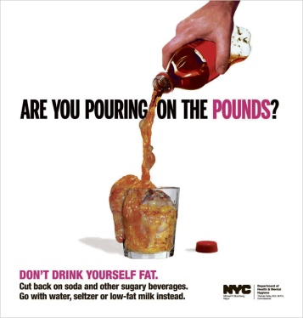
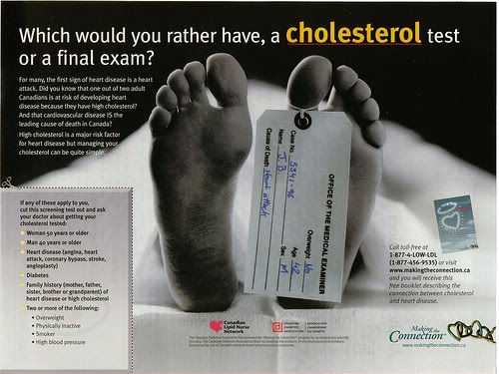
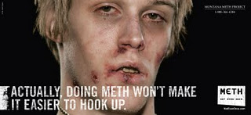

Conclusion:
- Elements of horror are not just used for stories and movies
- The reason why they use horror elements in the news and advertising is because we are drawn to horror and deeply affected by it

Maybe if it bleeds, it really does lead...

