Snow White Deconstruction Questions
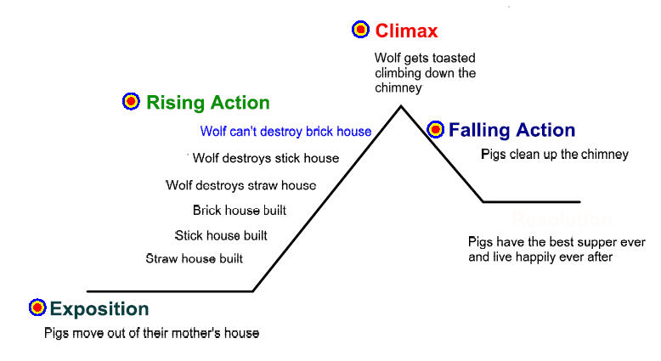
As you read Snow White, complete the following questions below. These will be taken up as a class, so ensure you write down your answers.

- Create a plot graph listing the events of this story.

- List the characters in Snow White, determine the archetype they represent, and explain how they fit that archetype by referring to events in the story.

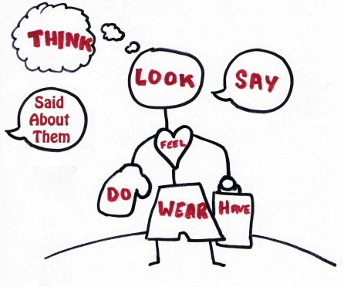
- Create a character sketch of Snow White using the diagram below, and use it to explain whether or not you think she is a dynamic character.

- List the types of conflicts found in Snow White (man vs. self, man, nature, supernatural)

- Identify the moral of the story. Explain it using references to the story.

- Create a theme statement for this story.

Snow White Deconstruction Questions
As you read Snow White, complete the following questions below. These will be taken up as a class, so ensure you write down your answers.

- Create a plot graph listing the events of this story.

- List the characters in Snow White, determine the archetype they represent, and explain how they fit that archetype by referring to events in the story.

- Create a character sketch of Snow White using the diagram below, and use it to explain whether or not you think she is a dynamic character.

- List the types of conflicts found in Snow White (man vs. self, man, nature, supernatural)

- Identify the moral of the story. Explain it using references to the story.

- Create a theme statement for this story.

