Billy Mitchell  (The Champion) | Walter Day  (The Referee) | Steve Wiebe  (The Challenger)
How do you feel about him? | How do you feel about him? | How do you feel about him?
How is your opinion formed? (provide examples)  Character:  Emotions:  Logic: | How is your opinion formed? (provide examples)  Character:  Emotions:  Logic: | How is your opinion formed? (provide examples)  Character:  Emotions:  Logic:
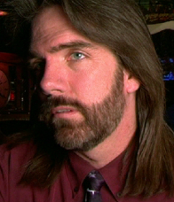
Name: Total: LV

Pre-Viewing Questions
- What is your opinion of videogames?

- Do you think it’s possible to become addicted to videogames?

- Should professional gamers be treated as celebrities or athletes?

Post-Viewing Research
Answer the following questions after reading the provided articles.
- What is your opinion of these gamers? Are they wasting their time, or paving the way for professional gamers? Why do you think this?

- Read the provided article(s)What facts did the King of Kong: A Fistful of Quarters documentary leave out? How would this have changed the story?

- How does this new information change your perspective of the gamers?

