Theatrical Terms for ENG 2DI

Allusion: A cultural reference to a well-known work, figure, or character
Archetype: A character type which theatrical characters are based upon
Dramatic Irony: When the audience knows something a specific character does not
Comic Relief: Humor used to break the tension of a dramatic scene

Protagonist: The central character of a play
Antagonist: The rival character in the play
Motivation: Reasons behind a character’s actions

Genre: A type of play
Comedy: A play that focuses on humorous situations and the prevalence of love
Tragedy: A play in which the hero is destroyed because of an imbalance in his character
Tragic Flaw: The defect of the tragic hero’s character
Crisis: An important turning point in a story
Catastrophe: The final event in a tragedy in which the hero is overthrown and meets his death
Catharsis: The release from fear and pity as a purpose of tragedy

Soliloquy: A speech revealing a character’s thoughts to the audience while the character is alone on stage
Blank Verse / Prose: Speech that does not rhyme or have any restrictions of meter. Often used by uneducated characters
Poetry: Structured speech, following a rhyme scheme and specific meter
Iambic Pentameter: Shakespeare’s predominant form of poetry used in his plays
Iam = Unstressed syllable followed by a stressed syllable
Penta = five
Meter = feet in a line of poetry
Foot = two syllables
Couplet: Two consecutive lines that rhyme
Sonnet: A 14 line poem, traditionally about love. It includes shifts to analyze a topic from multiple perspectives

Prologue: An opening speech, which introduces the play
Pathos: An attempt by the author to build pity or sympathy for a character
Paradox: A statement which seems contradictory but is actually true
Pun: A play on words
Supernatural: A divine power extending beyond the mortal realm
Suspense: The building of anticipation
Motif: A recurring image or phrase
Symbolism: An object used to represent a complex idea
Theme: A message the author sends to audiences through their work
Universal Theme: A thematic statement that transcends a specific work, and can apply to all peoples, cultures, and eras (ie. family, fate, tragedy, love, justice, etc.)
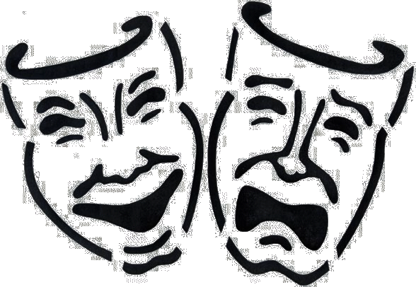

Theatrical Terms for ENG 2DI

Allusion: A to a well-known work, figure, or character
Archetype: A which theatrical characters are based upon
Dramatic Irony: When the knows something a specific character does not
Comic Relief: Humor used to break the of a dramatic scene

Protagonist: The character of a play
Antagonist: The character in the play
Motivation: behind a character’s actions

Genre: A type of play
Comedy: A play that focuses on and the prevalence of
Tragedy: A play in which the because on an in his character
Tragic Flaw: The of the tragic hero’s character
Crisis: An important in a story
Catastrophe: The in a tragedy in which the hero is and meets his death
Catharsis: The release from as a purpose of tragedy

Soliloquy: A speech revealing a to the audience while the character is
Blank Verse / Prose: Speech that does not or have any . Often used by characters.
Poetry: , following a rhyme scheme and specific meter
Iambic Pentameter: Shakespeare’s predominant form of used in his plays.
Iam = followed by a stressed syllable
Penta =
Meter = in a line of poetry
Foot =
Couplet: Two consecutive lines that
Sonnet: A poem, traditionally about . It includes to analyze a topic from multiple perspectives

Prologue: An , which introduces the play
Pathos: An attempt by the author to build for a character
Paradox: A statement which seems but is actually true
Pun: A on words
Supernatural: A extending beyond the mortal realm
Suspense: The building of
Motif: A recurring
Symbolism: An used to represent a
Theme: A the author sends to audiences through their work
Universal Theme: A thematic statement that , and can apply to all (ie. family, fate, tragedy, love, justice, etc.)

